Tissues
Are groups of cells that lie together to accomplish a common function. During the early developments of embryo, there are three primitive germ layers: ectoderm, mesoderm, and endoderm. From these germ layers the tissues formed and the body is developed. The human body composed of four basic types of tissue: epithelial, connective, muscular and nervous tissues. These tissues exist in association with one another and in variable proportions, forming different organs and systems of the body. The organ can be divided into parenchyma which is composed of the cells responsible for the main function typical of the organ, and stroma, which is the supporting tissue.
Epithelial cells are derived from all three embryonic germ layers which cover the body surfaces and line the body cavities. Connective tissue derived from mesoderm which supports the other three basic tissues, both structurally and functionally. Muscle tissue derived from mesoderm which is made up of contractile cells specialized for contraction and movements. Nervous tissue derived from ectoderm which composed of nervous cells that have the specialized functions of receiving, generating, and transmitting nerve impulses, and integrates information from outside and inside the body.

Epithelial tissue
It is one of the four major tissue types in the body, acting as an interface between the body and the rest of the world and has a special function because it must cover all the surfaces of the body, therefore it is found in our skin, and it is also found covering all the surfaces of the openings (each one is called a lumen) within our bodies.
It is made up of cells closely packed and ranged in one or more layers. Epithelial cells are packed tightly together, with almost no intercellular spaces and only a small amount of intercellular substance.

Basal lamina and basement membrane
All epithelium rests on a sheetlike extracellular structure called basal lamina that is not visible under the light microscope. This layer contains type IV collagen, laminin, entactin and proteoglycan. Under the electron microscope, the basal lamina appears as a denser layer, 20-100 nm thick, consisting of a delicate network of fine fibrils (lamina densa).
The epithelial cells produce the basal lamina .In some instances, reticular fibers (formed by connective tissue cells) are closely associated with the basal lamina, forming the reticular lamina.
The term basement membrane usually contains two fused basal laminae or a basal lamina and reticular lamina.
The basal lamina forms a sieve-like barrier between the epithelium and connective tissue.
The functions of the basal lamina include:
Structural support, it provides strong connection between epithelium and underlying connective tissue.
Filtering, the basal lamina forms a semi-permeable barrier limiting or regulating exchanges of macromolecules between epithelium and underlying connective tissue and organizing the proteins in adjacent plasma membrane.
Basement membrane proteins have been found to facilitates differentiation of endothelial cells (a single cell layer lines all blood vessels) and this cells are essential for development of new blood vessels or angiogenesis.
Defects and disruptions of the basal lamina lead to many pathological conditions, e.g. glomerulonephritis.

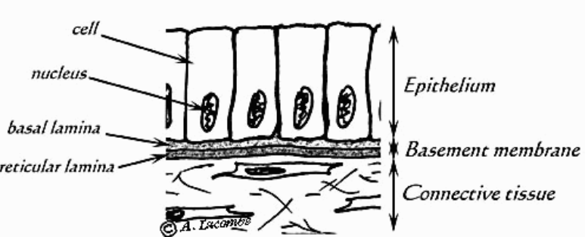
Diagrammatic illustration showing epithelial cells resting on basement membrane.

Main Characteristics of Epithelium

An epithelium is a continuous sheet of connected cells that covers or lines a body surface (e.g. skin, intestine), also secretory glands (e.g. sweat, salivary, mammary) are derived from epithelium.
An epithelium contains very little extracellular matrix.
An epithelium sits on a basal lamina.
Epithelium does not contain blood vessels, therefore said to be avascular. Nutrients reach cells epithelium via diffusion from blood vessels outside the basal lamina, (it is instead supported by capillaries in connective tissues, which supply the epithelial tissue with nutrients through a process called diffusion).
These cells are often characterized by frequent cell division because they are exposed to wear and tear and injury, necessitating replacement.
Derived from all embryonic germ layers, including endoderm, mesoderm and ectoderm.

Functions of epithelium
Protection
Epithelial cells from the skin protect underlying tissue from mechanical injury, harmful chemicals, invading bacteria and from excessive loss of water.
Sensation
Specialized epithelial tissue like skin, eyes, ears, nose and the tongue, containing sensory nerve endings to detect any changes in the external environment at their surface.
Secretion
In glands, epithelial tissue is specialized to secrete specific chemical substances such as enzymes, hormones and lubricating fluids.

Absorption
Certain epithelial cells lining the small intestine absorb nutrients from the digestion of food.

Excretion
Epithelial tissues in the kidney excrete waste products from the body. Sweat is also excreted from the body by epithelial cells in the sweat glands.

Diffusion
Simple epithelium promotes the diffusion of gases, liquids and nutrients. Because they form such a thin lining, they are ideal for the diffusion of gases e.g. walls of capillaries and lungs).)

Cleaning
Ciliated epithelium assists in removing dust particles and foreign bodies which have entered the air passages.

Reduces Friction
The smooth, tightly-interlocking, epithelial cells that line the entire circulatory system (endothelium) reduce friction between the blood and the walls of the blood vessels.

Renewal of cell epithelia
The cells of epithelial tissue are capable of rapid division, which is the process that creates new cells. Many epithelial cells, in different parts of the body, are lost due to friction or exposure to harmful substances. The skin, for instance, constantly produces new cells to replace the dead cells closest to the skin's outer surface. The cells of tissues lining the digestive tract, including those of the esophagus, stomach, and intestines, also undergo continuous division.

